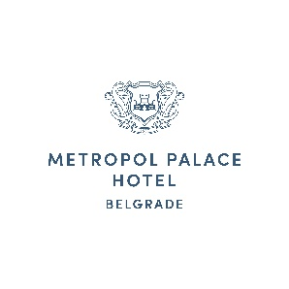
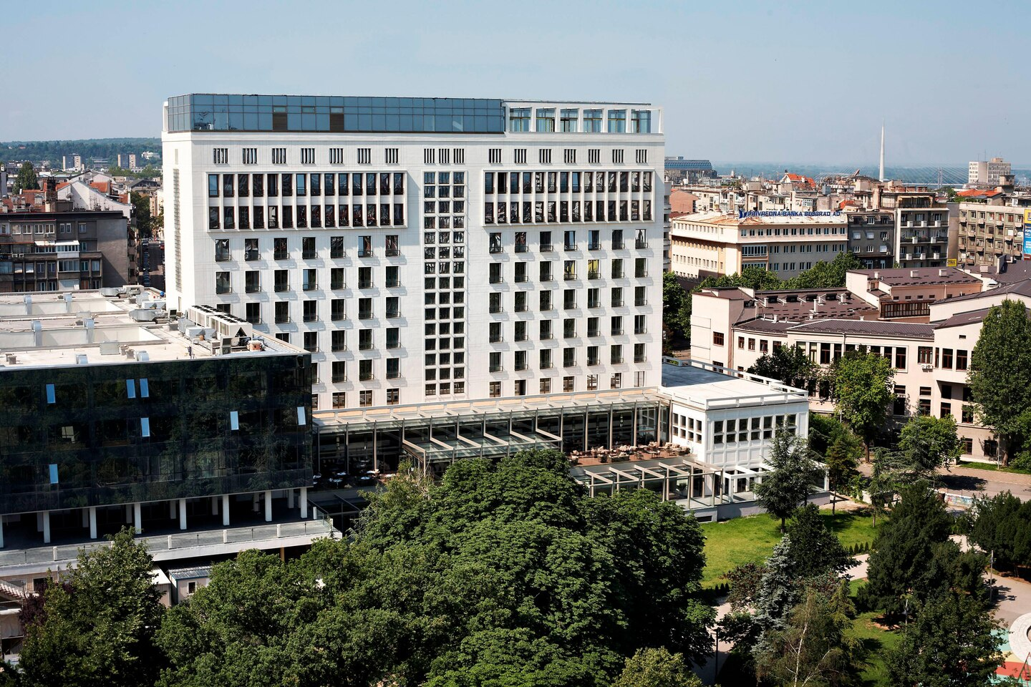
YOUR WELCOME AWAITS. METROPOL PALACE BELGRADE

Dear FIC members,

We hope that you and your families are healthy and that you are back on track with your business activities. It is with great pleasure to announce that our Hotel is officially open again. Metropol Palace follows every guideline and regulation regarding cleanliness and protection of guests, as well of our associates. You are welcome to visit us and look forward to making memories again together. We missed you!

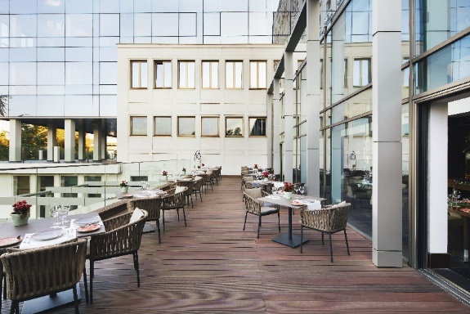
Your favorite routine of first morning coffee,
deserved time for yourself, break or afterwork rest.
We all need it.
Lobby bar and terrace, open for beverage every day
From 09.00-23.00 hours
A la carte breakfast. From 08.00-11.00 hours
44 Red Parallel restaurant

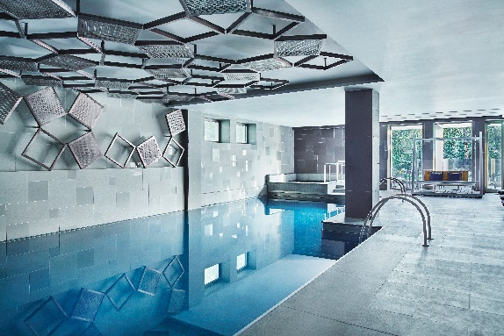

We are completely aware that going back in good shape is necessity.
With relaxing in treatments and specially created massages, or unwinding in our 25m long pool.
Possible every day from 09.00-22.00 hours
Limegrove Wellness & Spa centre

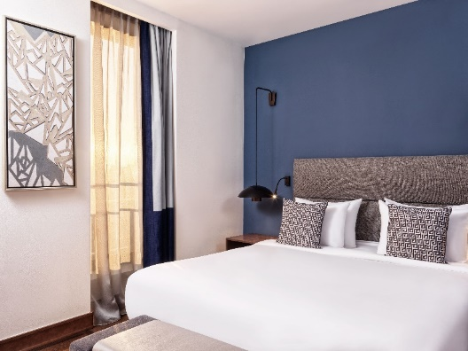
Comfort and quality in central city location, left as constant, regardless new nature of travel.
Summer offer for FIC members:
- 80 EUR single use on bed and breakfast basis for stays until 10 nights
- Additional 10% discount for 10+ nights (long stays)
- Free upgrade to Superior room
- 50% discount for parking
Offer is valid till 7th of September, 2020.
Contact us for other Staycation offers and benefits for first come basis reservations, made until 31.08.2020.

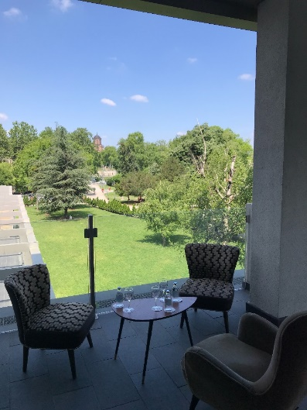
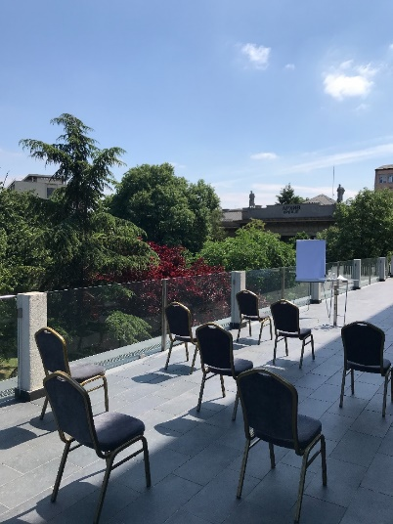
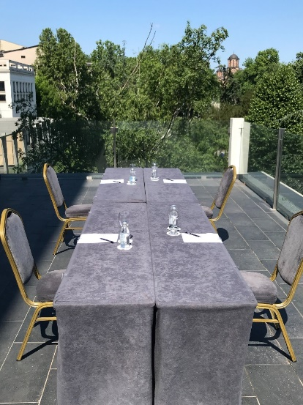

If you need outdoor space for meeting, conference call or small celebration, we got you all covered.
We will be glad to organize it in one of the various outside venue possibilities.
Benefits of daylight, covered or divided spaces, and lot of opportunities for social distancing measures and flexible set ups. Meeting rooms, terraces and garden of Metropol Palace Belgrade.

Different approach. Different events. Hotel that defines destination. Event to remember.
Clean. Safe.

Didn’t you book your place yet?
Metropol Palace Belgrade sales team
salesteam@metropolpalace.com │+381 11 3333 127

